**Project Report**

**on**

**“ ONLINE LIBRARY MANAGEMENT SYSTEM”**



**SRI BALAJI UNIVERSITY**

**SCHOOL OF COMPUTER STUDIES**

**Program: Masters of Computer Application**

**2023 Batch**

**SUBMITTED BY:**

**Nitin Yadav (MCA2302036)**

**Shyam Thakkar (MCA2302015)**

**Tanmay Hande (MCA2302094)**

CERTIFICATE

Certified that the Project Report entitled **“ONLINE LIBRARY MANAGEMENT SYSTEM”**, submitted by **Nitin Yadav, Shyam Thakkar, Tanmay Hande** of MCA, is their own work and has been carried out under my supervision. It is recommended that the candidates may now be evaluated for their work by the University.

**Name 1:Nitin Yadav Roll no: MCA2302015 Name 2: Shyam Thakkar Roll no: MCA2302036 Name 3: Tanmay Hande Roll no: MCA2302094**

**Date: - 10/10/2024**

**Place:- SBUP**

**Dr.G.Y.Shitole Prof. Rajasmita Panda**

**(Principal) (Assistant Professor)**

**ACKNOWLEDGEMENT**

We feel immense pleasure to introduce “**ONLINE** **LIBRARY MANAGEMENT SYSTEM**” as our major project. I express my sincere thanks to our instructor **Prof.** **Rajasmita Panda** who guided us to the successful completion of this project report. We take this opportunity to express our deep sense of gratitude for their individual guidance, constant encouragement and immense motivation which have sustained our efforts at all stages of this project report. We are grateful and appreciate all the staff members of the School of Computer Application for their cooperation and support.

I extend my sincere thanks to our **Principal Dr.G.Y.Shitole** and **Vice Principle Dr .Richa Purohit** for his support and for all the facilities provided for the preparation of this project report.

Also, we wish to thank our parents & friends who helped us a lot in collecting data, pictures and continuous help and support.

Finally, we would wish to thank everyone involved in this project time.

**ABSTRACT**

The Online Library Management System is a web-based application designed to automate the

management of library operations. Built using HTML, CSS, PHP, and MySQL, the system aims to

provide a streamlined solution for both librarians and users, making it easier to manage books, users,

and transactions. Our objective is to create an efficient platform that enhances accessibility to

library resources while simplifying the management process for administrators.

This system proves to be a significant improvement over the traditional manual processes. Users

can browse, reserve, and borrow books without having to physically visit the library, while library

staff can manage book inventories, track user transactions, and maintain records efficiently. The

system benefits educational institutions, public libraries, and organizations that aim to provide easy

access to a wide range of learning resources.

The primary aim of the project is to replace the existing manual system with an automated solution

that leverages computerized tools to store, retrieve, and manage valuable data for longer periods.

This not only improves the overall performance of the library but also ensures the availability of

resources to users with minimal effort and better service delivery. The system is designed to offer a

user-friendly experience while ensuring that data is securely stored and easily accessible for

future .

**TABLE OF CONTENT**

|  |
| --- |
| **Chapter 1 : INTRODUCTION TO THE LANGUAGES USED** **8** |
| 1.1 HTML & CSS |
| 1.2 INTRODUCTION TO PHP |
|  |
| **Chapter 2 : INTRODUCTION TO “Library Management System”** **9-12** |
| 2.1 INTRODUCTION |
| 2.2 PURPOSE & SCOPE |
| 2.3 EXISTING SYSTEM |
| 2.4 ADVANTAGES |
| 2.5 SRS |
| 2.6 USE |
| 2.7 PURPOSE |
| 2.8 FUNCTIONAL REQUIRMENTS |
| 2.9 NON- FUNCTIONAL REQUIRMENTS |
| 2.10 SOFTWARE TOOLS |
| 2.11 DEPLOYMENT |
| 2.12 FEASIBILITY STUDY |
|  |
| **Chapter 3 : DIAGRAMS** **13-21** |
| 3.1 ENTITY RELATIONSHIP DIAGRAM |
| 3.2 DATA FLOW DIAGRAM |
| 3.3 USE CASE DIAGRAM |
| 3.4 CLASS DIAGRAM |
| 3.5 ACTIVITY DIAGRAM |
| 3.6 SEQUENCE DIAGRAM |
| 3.7 DEPLOYMENT DIAGRAM |

|  |
| --- |
| **Chapter 4: DATA MODEL 22- 23** |
| 4.1 TABLE STUDENT |
| 4.2 TABLE ISSUED_BOOK |
| 4.3 TABLE CATEGORY |
| 4.4 TABLE BOOK |
| 4.5 TABLE AUTHOR |
| 4.6 TABLE ADMIN |
|  |
| **Chapter 5: USER INTERFACE** **24-32** |
| 5.1 USER LOGIN FORM |
| 5.2 USER SIGN-UP FORM |
| 5.3 USER DASHBOARD |
| 5.4 USER MANAGE ISSUED BOOK |
| 5.5 USER MY PROFILE |
| 5.6 USER CHANGE PASSWORD |
| 5.7 ADMIN LOGIN FORM |
| 5.8 ADMIN DASHBOARD |
| 5.9 ADD BOOK CATEGORY |
| 5.10 MANAGE BOOK CATEGORY |
| 5.11 MANAGE BOOK AUTHORS |
| 5.12 ADD BOOK AUTHORS |
| 5.13 ADD BOOK |
| 5.14 MANAGE BOOK |
| 5.15 ISSUE NEW BOOK |
| 5.16 MANAGE ISSUED BOOKS |
| 5.17 MANGE REGISTERED STUDENT |
| 5.18 ADMIN USER CHANGE PASSWORD |
|  |
| **Chapter 6: TEST CASE 33-35** |
| 5.1 Module Testing |
|  |
| **Chapter 6: CONCLUSION & FUTURE SCOPE 36** |
|  |
| **Chapter 7:BIBLOGRAPHY & REFERENCE 37** |

**Chapter 1: INTRODUCTION TO THE LANGUAGES USED**

**1.1 HTML & CSS**

* **HTML:**

Html stands for Hyper Text Markup Language. It is the standard markup language for creating Web pages, which describes the structure of a Web page. HTML consists of a series of elements that tell the browser how to display the content. These elements label pieces of content such as "this is a heading", "this is a paragraph", "this is a link", etc.

Developer of HTML: Tim Berners-Lee

* **CSS :**

CSS stands for Cascading Style Sheets. This language describes how HTML elements are to be displayed on screen, paper, or in other media. It saves a lot of work, and can also control the layout of multiple web pages all at once. External stylesheets are stored in CSS files with .css extension. Developer of CSS : World Wide Web Consortium (W3C)

* 1. **INTRODUCTION TO PHP:**

Certainly PHP (Hypertext Preprocessor) is a widely used server-side scripting language primarily designed for web development. It is used to create dynamic web pages by embedding PHP code within HTML. When a user requests a web page that contains PHP code, the server processes the PHP code and sends the resulting HTML to the user's web browser, which displays the page.

**Chapter 2:-INTRODUCTION TO**

**"LIBRARY MANAGEMENT SYSTEM"**

* **Introduction:**

The "Library Management System" is a web-based application designed to provide efficient

and reliable services for managing library operations. The platform is tailored to help educational

institutions, public libraries, and other organizations manage their book inventories, user data, and transactions seamlessly. Our primary objective is to make the system user-friendly, allowing both administrators and users to access library resources without hassle.

We provide a secure platform where users can easily browse, borrow, and return books, while

librarians can manage book inventories and user records effectively. The system replaces manual,

time-consuming processes with an automated and streamlined approach. This eliminates the need for physical visits for basic tasks such as checking book availability or updating borrowing records,

offering an online solution for modern libraries.

* **Purpose:**

The Library Management System is designed to help both libraries and users by making the

management and access to library resources more convenient and effective. It serves as a hub where librarians can manage the library’s catalog, check user records, and track borrowing history. Users

can also browse books, check availability, and borrow or reserve books online without needing to visit

the library in person.

This system simplifies library operations and provides a structured and secure environment

where both users and librarians can interact with ease. The purpose is to offer a solution that allows

quick access to information and promotes efficient handling of library resources. The platform also

ensures transparency by keeping track of every transaction, making it easier for users to access and manage their accounts and book loans.

* **Scope:**

The proposed Library Management System aims to address the limitations of the current manual

or semi-automated systems used in libraries. The system will be designed to improve the overall

user experience and enhance the efficiency of managing library resources.

The scope includes developing a user-friendly interface for both library staff and users,

ensuring easy navigation and functionality. The system will also incorporate a feedback mechanism, enabling users to review the services provided by the library, which will offer valuable insights for improving the

system’s performance and user satisfaction.

In addition to managing books and user accounts, the system will also allow for the integration

of other services like overdue notifications, automatic updates of borrowing records, and secure

management of sensitive data. Overall, the proposed system aims to provide a reliable, secure, and

easy-to-use platform for managing library resources.

* **Advantages:**

**- Convenience:** The Library Management System allows users to check the availability of books,

reserve or borrow them, and even return them from the comfort of their homes, eliminating the need

for physical visits.

**- Efficient Resource Management:** Librarians can manage book inventories, user records, and

borrowing transactions efficiently through an integrated system that automates repetitive tasks.

**- Time-Saving**: The system saves time for both users and library staff by automating processes such

as checking availability, issuing returns, and managing overdue books.

**- Reduced Errors:** Manual errors in managing library records can be reduced as the system ensures

data accuracy and transparency.

**- Accessibility:** Users can access the platform 24/7, allowing them to browse and borrow books at

their convenience, anytime, anywhere.

**- Information Access:** The system provides detailed information about the available books, including book descriptions, availability, and borrowing history.

* **Existing System**

- **Time-Consuming**: Book borrowing, returns, and catalog management rely on manual record-keeping, which consumes significant time and effort.

- **Prone to Errors**: Manual processes increase the chances of human errors, such as incorrect book entries, lost records, or misplaced books.

**-Difficulty in Tracking**: Tracking book availability, due dates, and borrower information can be inefficient and prone to inconsistencies, leading to lost or overdue books.

**-Limited Accessibility**: Users must physically visit the library to check the availability of books or to

borrow /return them, reducing convenience.

* **SRS - SOFTWARE REQUIREMENT SPECIFICATION:**

A Software Requirements Specification (SRS) is a detailed document that outlines what the software

is expected to do and how it should perform. It covers the functionality and requirements needed to

satisfy both business and user needs.

* **Use**

To create a platform where librarians can efficiently manage library operations and where

Users can easily access and borrow books and other resources.The Library Management System is

designed to bridge the gap between users and library resources, ensuring that information is

accessible and operations are smooth for everyone involved.

* **Functional Requirements**

1. User Registration and Authentication:

- Use: Allow students, teachers, and library staff to create accounts and log in securely.

- Purpose: To personalize user experience and ensure only authorized users can borrow, return, or manage books.

2. Book Borrowing and Return Management:

- Use: Enable users to borrow, reserve, or return books easily through the online platform.

- Purpose: To streamline book borrowing and returning processes for users and ensure proper

tracking.

3. Profile Creation for Users:

- Use: Each user (students, teachers, or staff) can create and manage their library profiles, view

book history, and track borrowing status.

- Purpose: To provide personalized access to library resources and keep track of individual activities such as borrowed books, overdue fines, etc.

4. Information Display:

- Use: Display information about available books, genres, authors, new arrivals, and

announcements related to the library.

- Purpose: To keep users informed about the latest updates and available resources in the library.

* **Non-Functional Requirements**

1. Security and Privacy:

- Purpose: Ensure that user data (borrowing history, personal information) is encrypted and secure.

The financial transactions for fines and fees must also be protected.

2. Scalability:

- Purpose: The system should be scalable to handle increasing numbers of users and an expanding collection of books over time.

3. Usability:

- Purpose: The interface should be user-friendly and intuitive, allowing easy navigation for users to search for books, reserve them, or view their borrowing history.

4. Performance:

- Purpose: Ensure quick loading times and responsive searches, especially during high-traffic

periods like the start of the school year or exam seasons.

5. Accessibility:

- Purpose: Design the system to be accessible to all users, including those with disabilities, by incorporating features like screen reader compatibility, alternative text, and accessible navigation.

6. Compliance and Regulation:

- Purpose: Ensure the system complies with local data protection regulations and library standards, including protection of personal information.

* **Software Tools**

1. Front-End:

- Tools: HTML, CSS for building the user interface, making it visually appealing and easy to use for

both students and library staff.

2. Back-End:

- Tools: PHP and MySQL for handling database management (books, users, reservations, and transactions) and processing book loans and returns.

* **Deployment**

- Operating System: Windows 10 server, with the option for web-hosting for wider accessibility by

students and staff from home or on-campus devices.

* **Feasibility Study**

**1. Technical Feasibility:**

- Infrastructure: Ensure the library has sufficient infrastructure, such as server capacity and a well-maintained database to support the expected number of users.

- Software & Development: Confirm the availability of necessary software (PHP, MySQL, hosting services) for the development and maintenance of the Library Management System.

- Integration: Assess the possibility of integrating the system with external databases, like ISBN databases, to automatically fetch book details during cataloging.

**2. Operational Feasibility:**

- User Acceptance: Conduct surveys or tests among potential users to ensure that the system will

be user-friendly and meets their expectations.

- Training and Support: Provide necessary training to library staff to use the system efficiently,

including adding new books, managing returns, and handling user queries.

**3. Economic Feasibility:**

- Cost Analysis: Evaluate the cost of building, hosting, and maintaining the Library Management

System, including any third-party software, licenses, and server hosting fees.

- Return on Investment (ROI): Estimate the benefits, such as improved efficiency, reduced manual workload, and better user satisfaction against the cost of development and operation.

**Chapter 3 DIAGRAMS**

### ENTITY RELATIONSHIP DIAGRAM

* + - **Data Flow Diagram**
      * **Level 0**

* + - * **Level 1**

* + - * **Level 2**

* + - **Use Case Diagram**

* + - **Class Diagram**

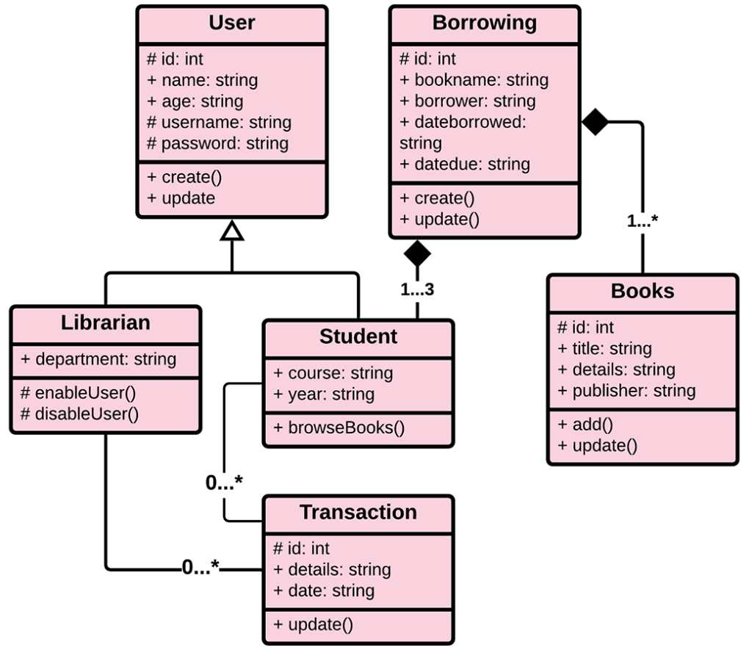

* + - **Activity Diagram**

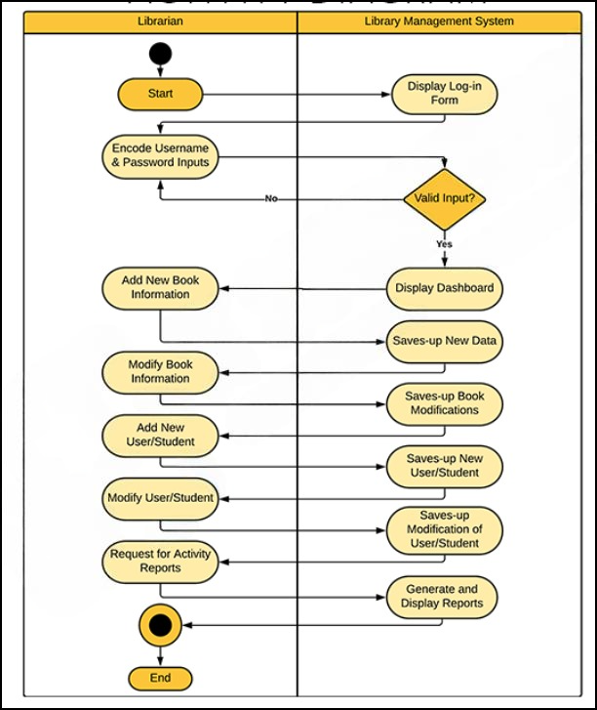

* + - **Sequence Diagram**

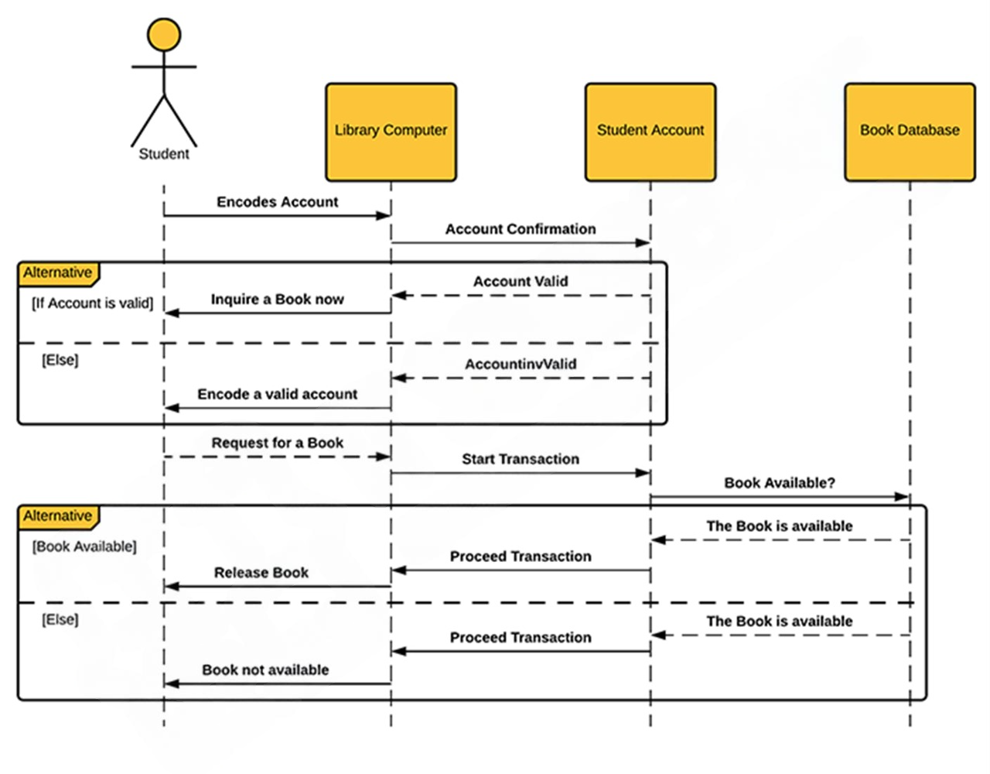

* + - **Deployment Diagram**

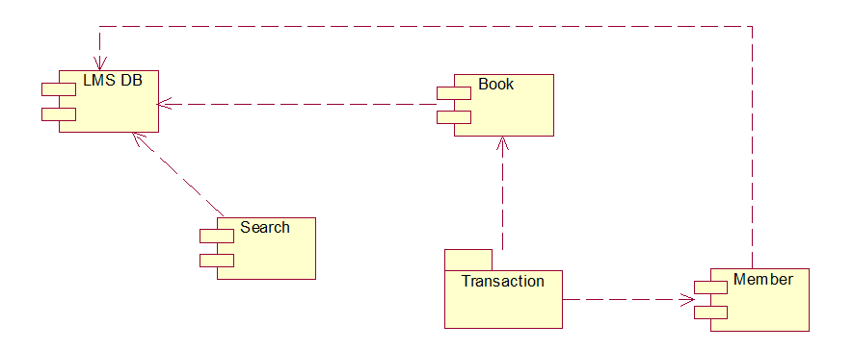

**Chapter No.4 Data Model**

**Table Student :-**

**Table Issued_Book:-**

**Table Category:-**

**Table Book:-**

**Table Author:-**

**Table Admin:-**

**Chapter 4: USER INTERFACE**

**4.1 User Login Form**

**4.2 User Sign-up form**

**4.3 User Dashboard**

**4.4 User Manage Issued Book**

**4.5 User My Profile**

**4.6 User Change Password**

**4.7 Admin Login Form**

**4.8 Admin Dashboard**

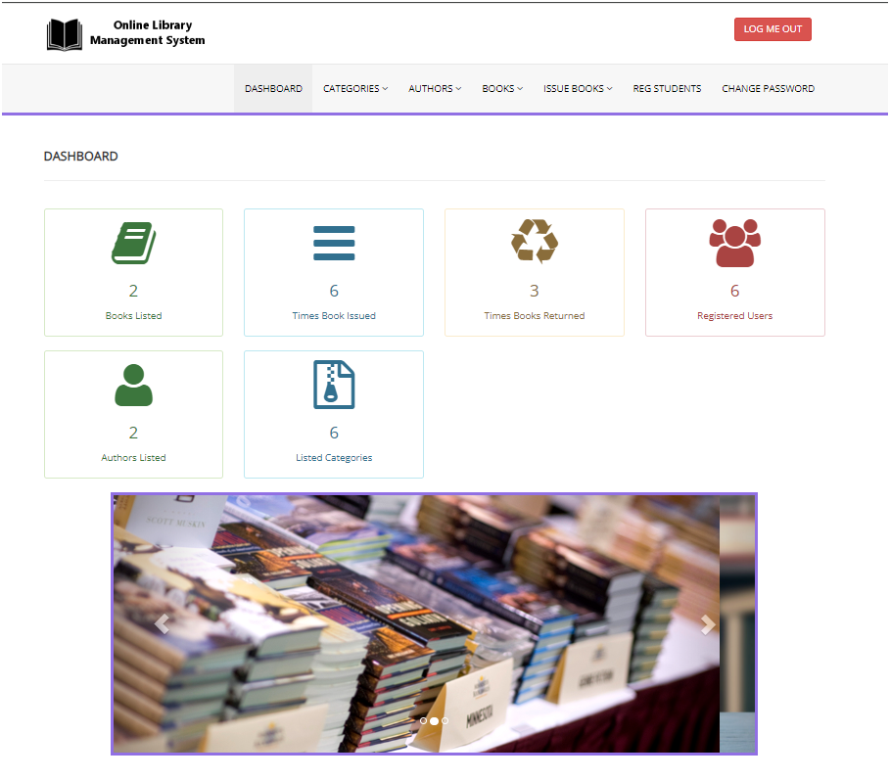

**4.9 Add Book Category**

**4.10 Manage Book Category**

**4.11 Manage Book Authors**

**4.12 Add Book Authors**

**4.13 Add Book**

**4.14 Manage Book**

**4.15 Issue New Book**

**4.16 Manage Issued Books**

**4.17 Mange Registered Student**

**4.18 Admin User Change Password**

**Chapter No 5 Test Case**

**Module Testing**

1. **User Authentication Module**

1. **User Profile Management Module**

1. **Book Management Module**

1. **Book Issue/Return Module**

1. **Category Management Module**

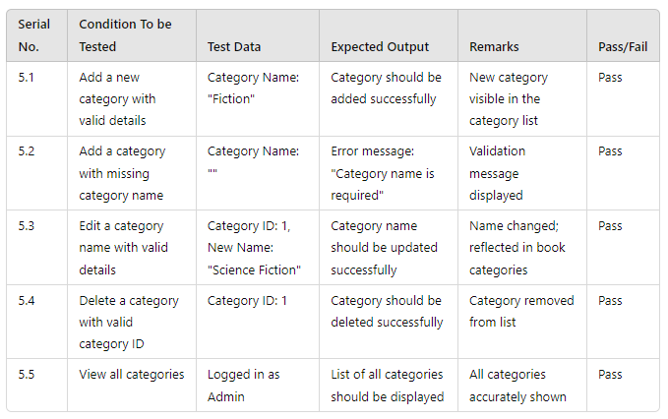

**Chapter No 6 Conclusion & Future Scope**

* **Conclusion**

A library management system is a valuable tool for libraries of all sizes**.** It automates tasks, improves accuracy, enhances accessibility, and provides data for better decision-making. By choosing

the right system, providing training, and maintaining it regularly, libraries can reap the benefits of

improved efficiency and cost savings.

* **Future Scope**

To enhance "THE LIBRARY MANAGEMENT SYSTEM," several improvements can be implemented:

1. Two-Factor Authentication

2. Feedback System

3. Automated Reporting

4. Payment System for Fine Payoff

**Chapter No 7 Bibliography & Reference**

W3C. (n.d.). Cascading Style Sheets (CSS). Retrieved from <https://www.w3.org/Style/CSS/>

 Berners-Lee, T. (n.d.). HTML: Hypertext Markup Language. Retrieved from <https://www.w3.org/MarkUp/>

PHP Group. (n.d.). PHP: Hypertext Preprocessor. Retrieved from <https://www.php.net/>

 Pressman, R. S. (2014). Software Engineering: A Practitioner's Approach (9th ed.). McGraw-Hill Education.

Sommerville, I. (2011). Software Engineering (9th ed.). Addison-Wesley